Om Gupta (EXT)

[Company name]  [Company address]

UAT-BPD Documentation Post-Upgrade

Index

**1] UAT-BPD Version 3**

**2] Home** 4

**3] Blueprints** 4

**3.1] bookmarked 4**

**3.2] Internal-Team** 4

3.2.1] Ashwani 4

3.2.2] project1 5

3.2.3] SOLO-LINUX 6

3.2.4] SOLO-WINDOWS **6**

3.2.5]SQL_CLUSTER-WIN 7

3.2.6]Test_run 7

3.2.7] UCD-AEP-MASTER8

3.2.8] UCD-AEP-MASTER-MOD8

3.2.9] VM-CREATE-LINUX **9**

3.2.10] VM-Folder-Creation 9

3.2.11] VM-Folder-Creation-Test 10

3.2.12] Windows 10

**4] Environments** 10

Terraform-UAT (TERRAFORM) **10**

**5] Repositories** 11

**6] Settings** 14

**6.1] Users** 14

**6.1.1] Internal Authentication** 14

6.1.1.1] Users **14**

6.1.1.2] Groups 15

6.1.1.3] Edit 15

**6.2] Roles** 16

6.2.1] Admin16

6.2.2] Blueprint Manager **16**

6.2.3] Environment Manager 17

6.2.4] Observer 17

6.2.5] Participant 18

6.2.6] QA Manager18

**6.3] Teams** 18

**6.3.1] Internal Team** 18

6.3.1.1] Members **18**

6.3.1.2] Cloud Connections19

6.3.1.3] OrchestrationConnections 20

**6.4] Orchestrations** 20

6.4.1] Terraform-UAT 20

**6.5] Cloud Connections** **20**

6.5.1] ALPHA-NON-WEBLOGIC 20

6.5.2]vALPHA-WEBLOGIC 21

6.5.3] BRAVO-NON-WEBLOGIC 22

6.5.4] BRAVO-WEBLOGIC 22

6.5.5] CHARLIE-NON-WEBLOGIC 23

6.5.6] CHARLIE-WEBLOGIC 23

6.5.7] DELTA-NON-WEBLOGIC 24

6.5.8] DELTA-WEBLOGIC24

**6.6] Modules** 25

**6.7] System Settings** **26**

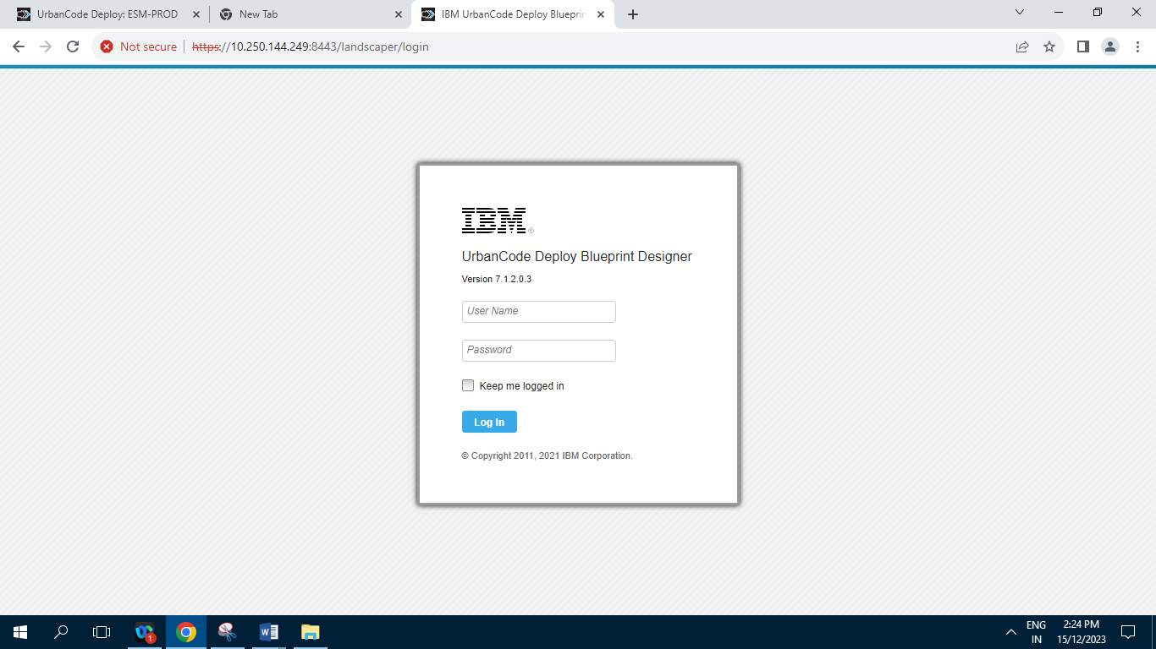

**1] UAT-BPD Version :**

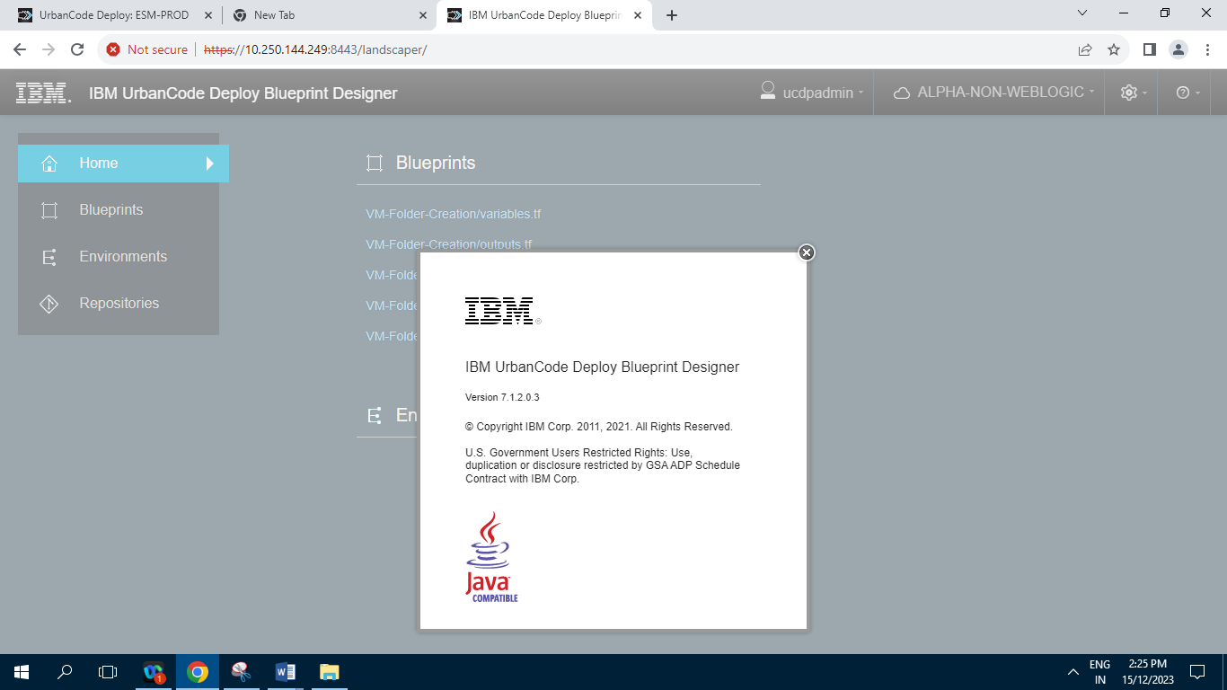

**2] Home**

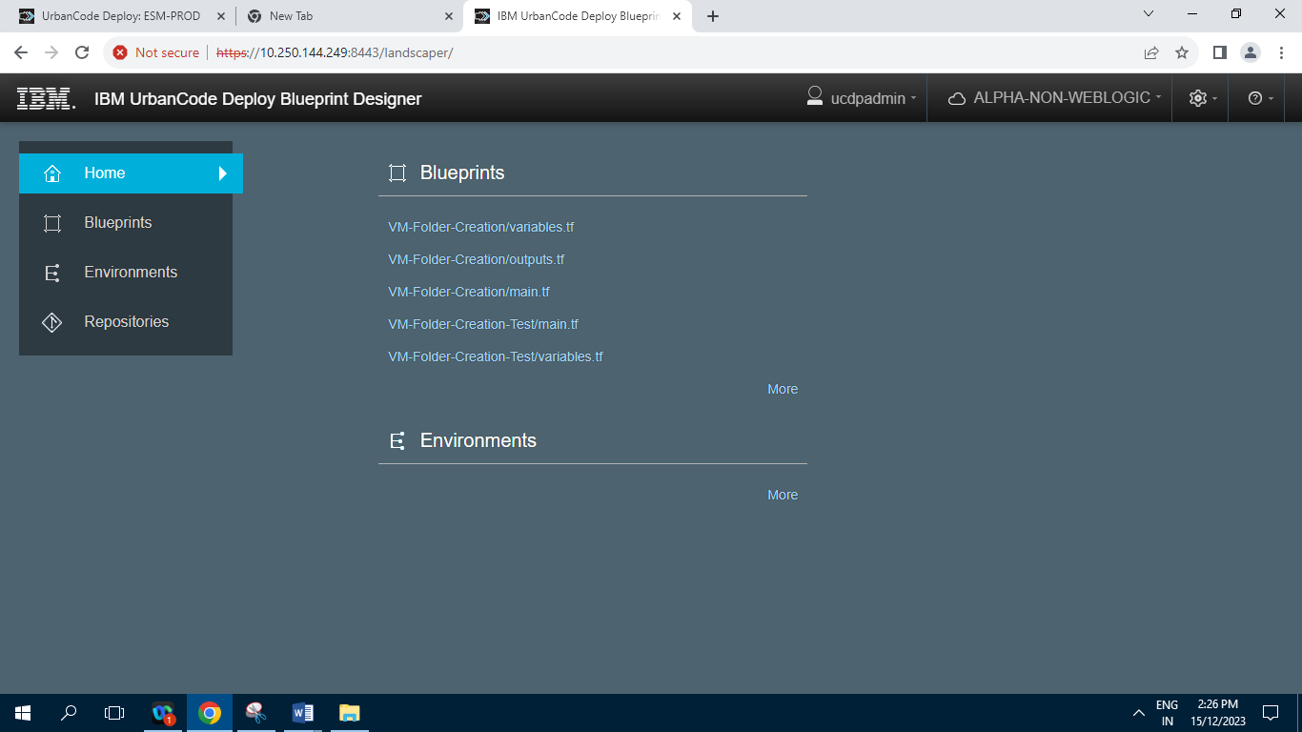

**3] Blueprints :**

**3.1] bookmarked**

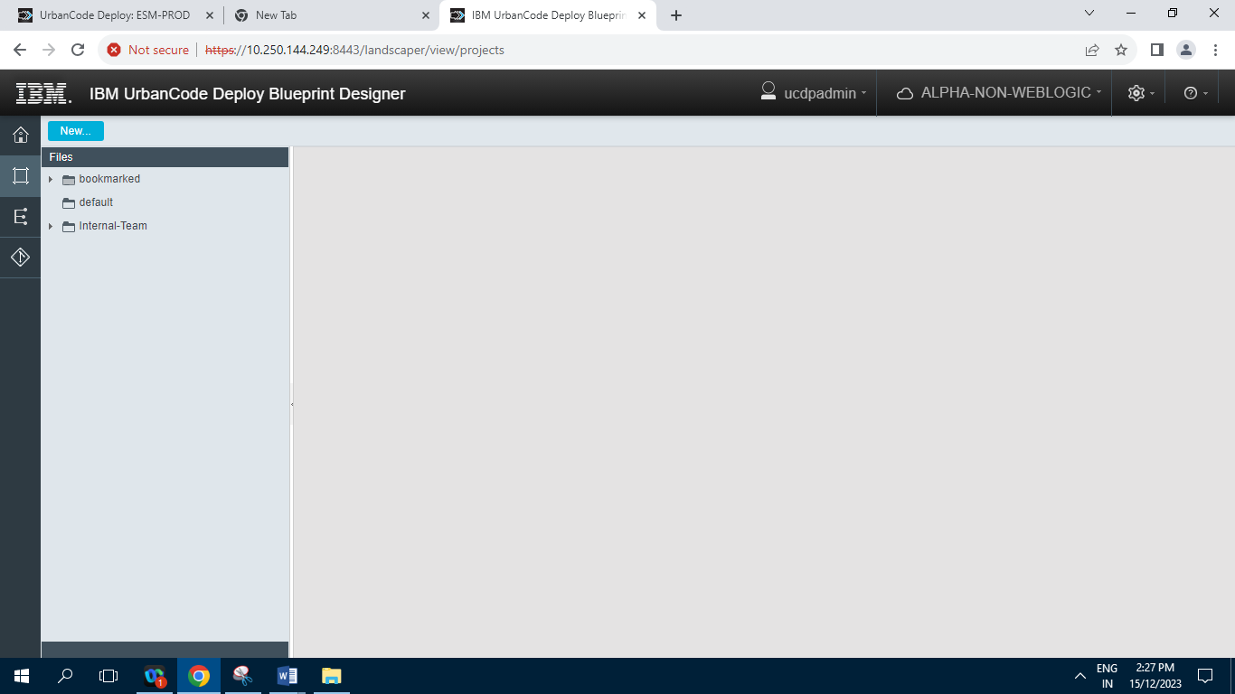

**3.2] Internal-Team**

**3.2.1] Ashwani**

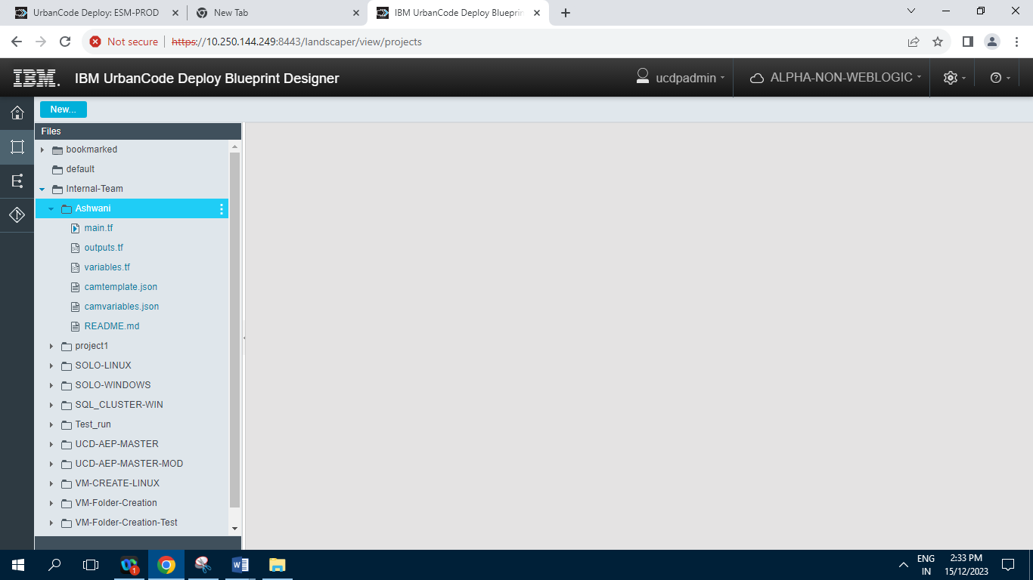

**3.2.2] project1**

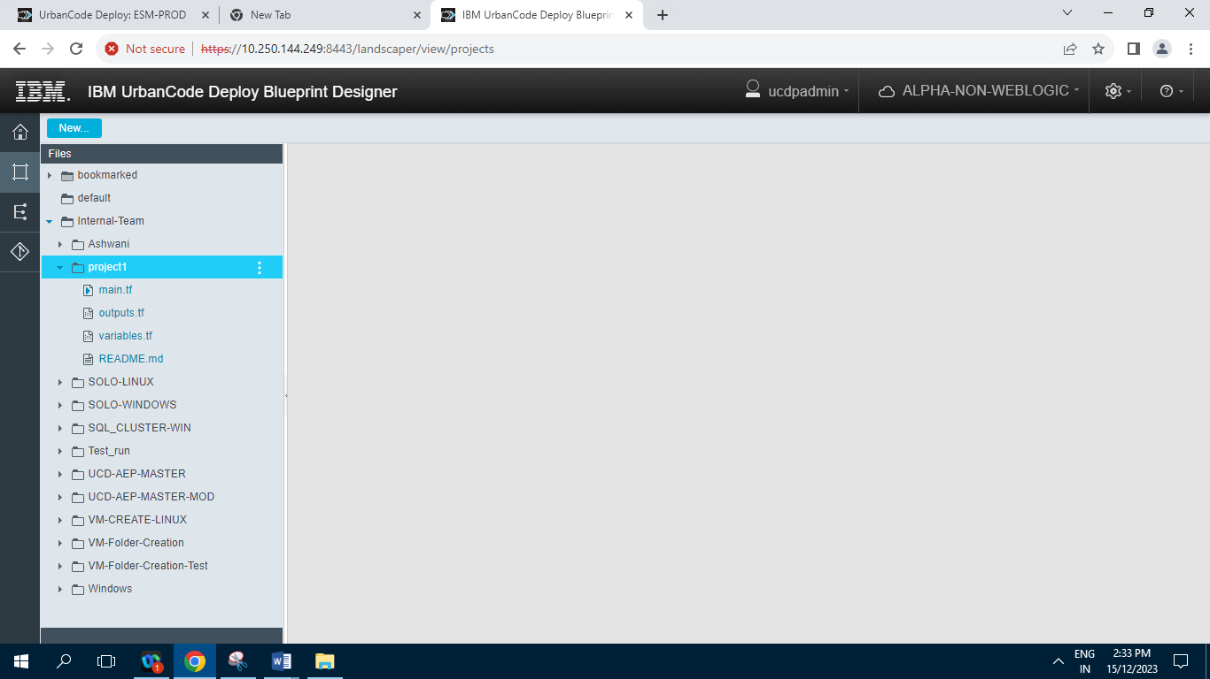

**3.2.3] SOLO-LINUX**

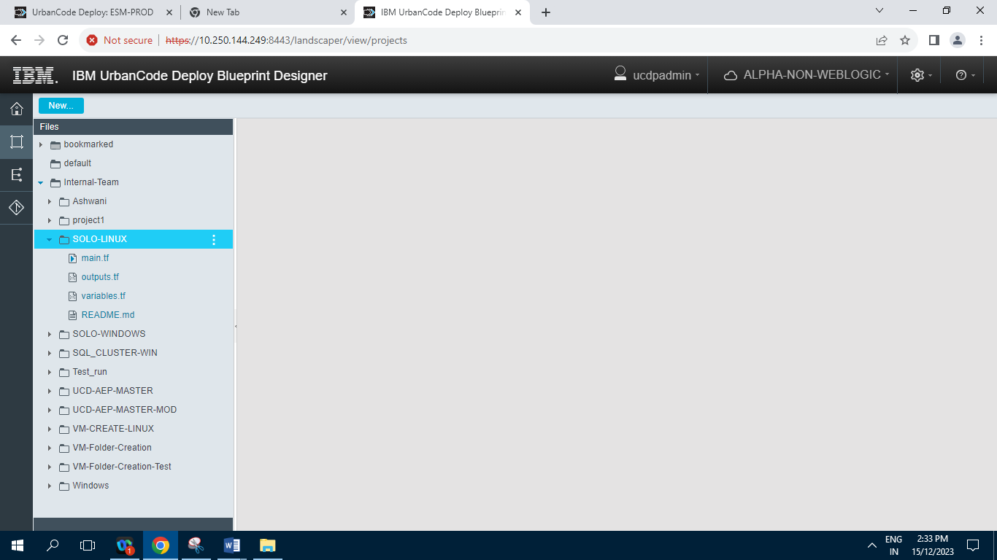

**3.2.4] SOLO-WINDOWS**

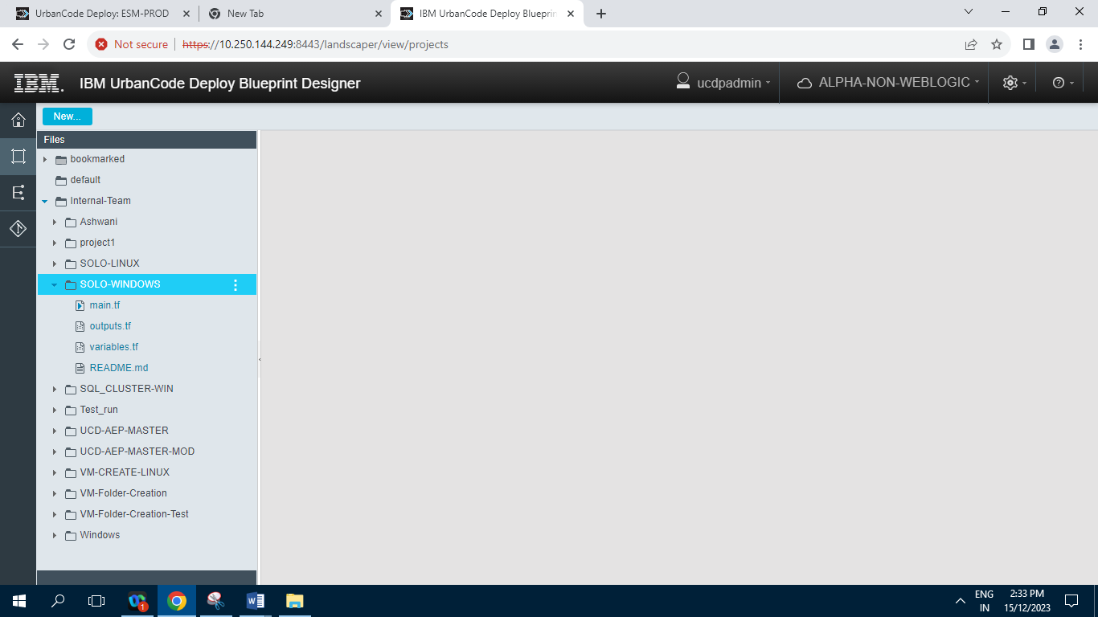

**3.2.5]SQL_CLUSTER-WIN**

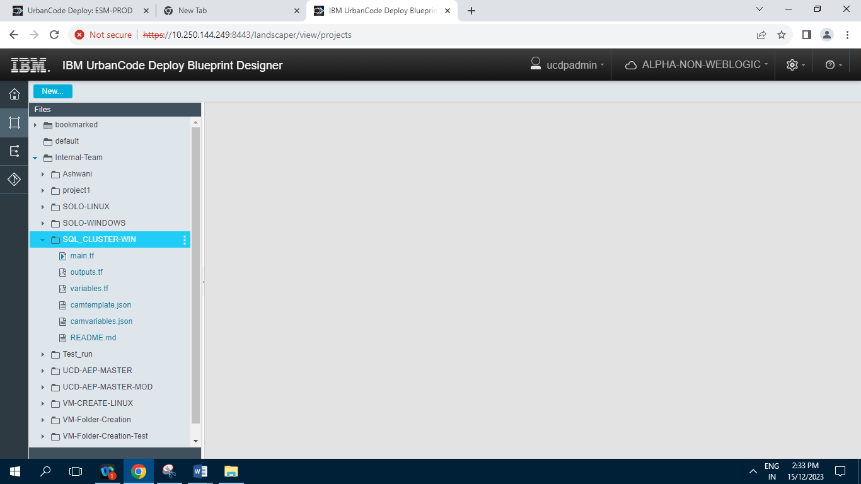

**3.2.6]Test_run**

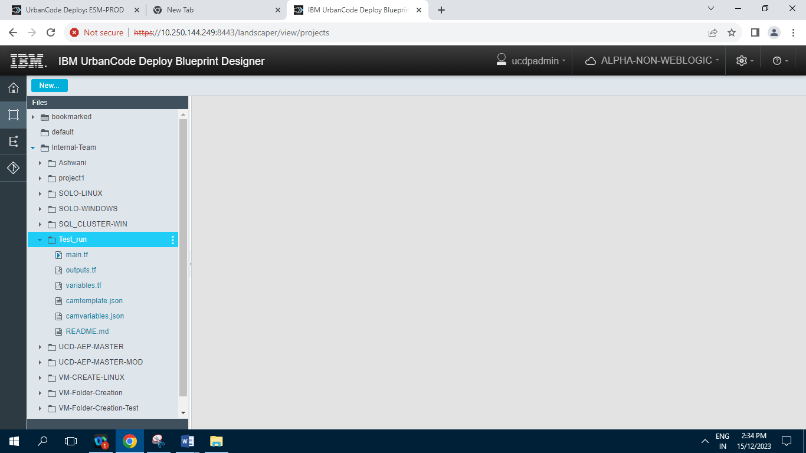

**.2.7] UCD-AEP-MASTER**

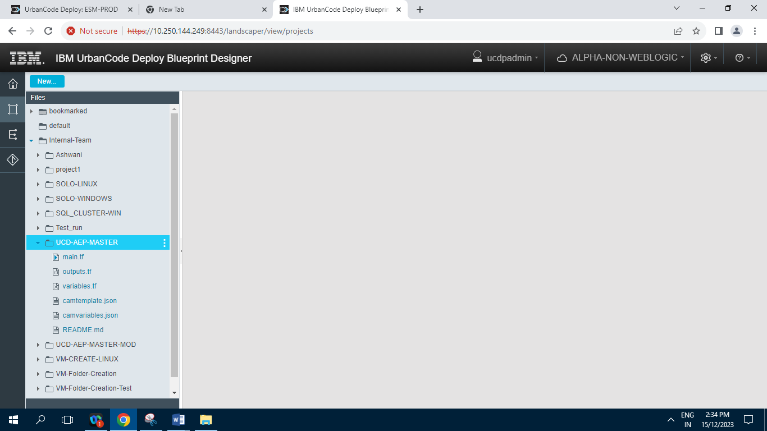

**3.2.8] UCD-AEP-MASTER-MOD**

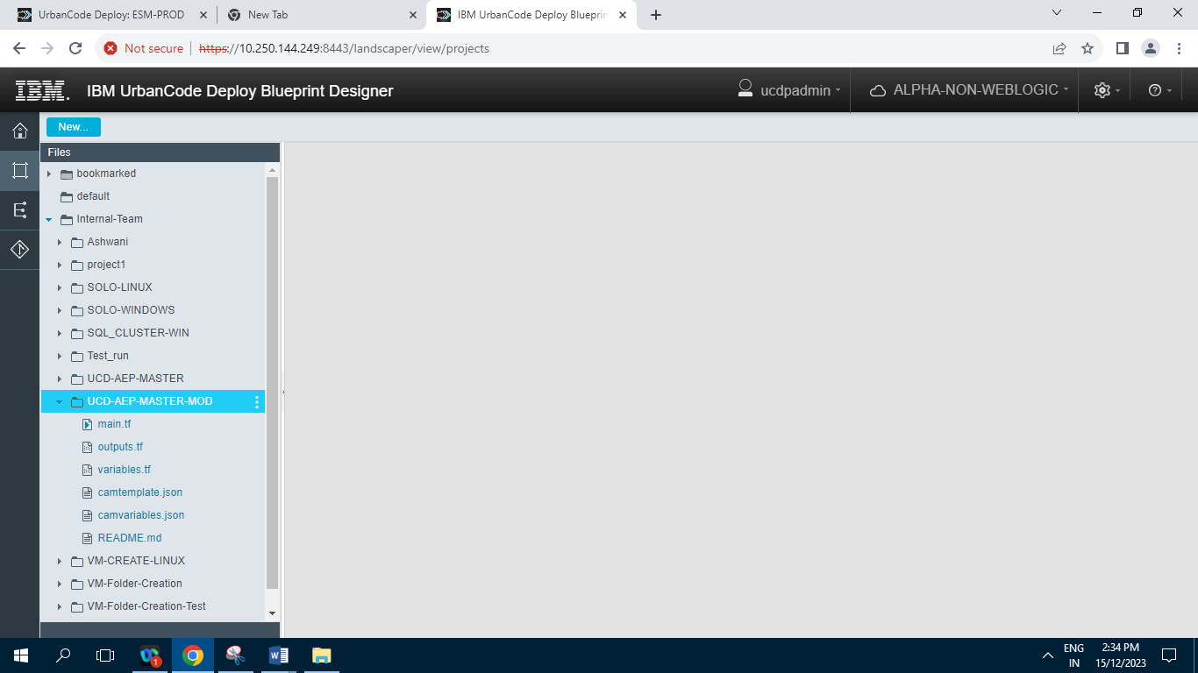

**3.2.9] VM-CREATE-LINUX**

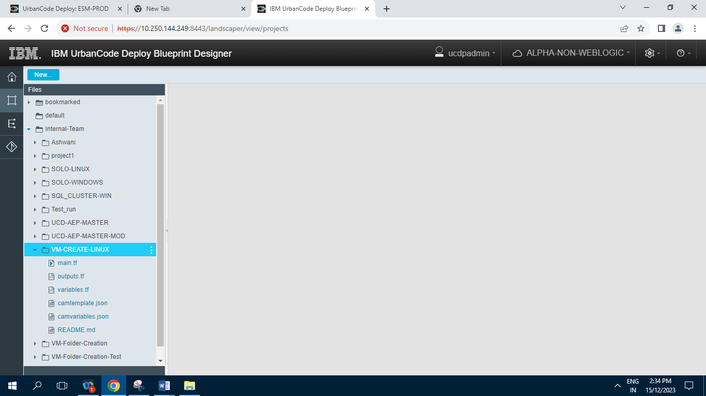

**3.2.10] VM-Folder-Creation**

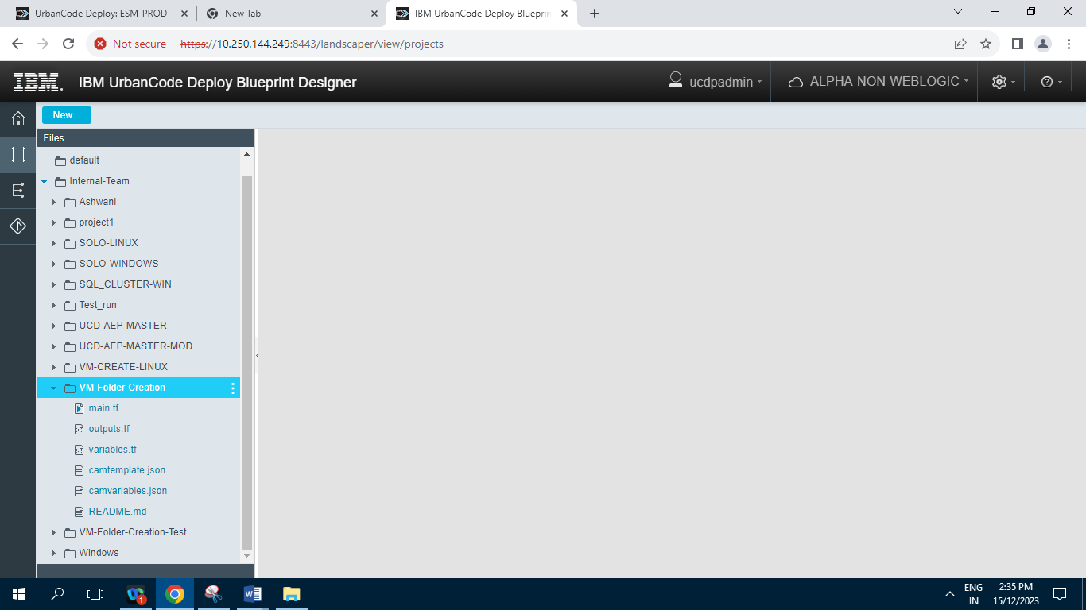

**3.2.11] VM-Folder-Creation-Test**

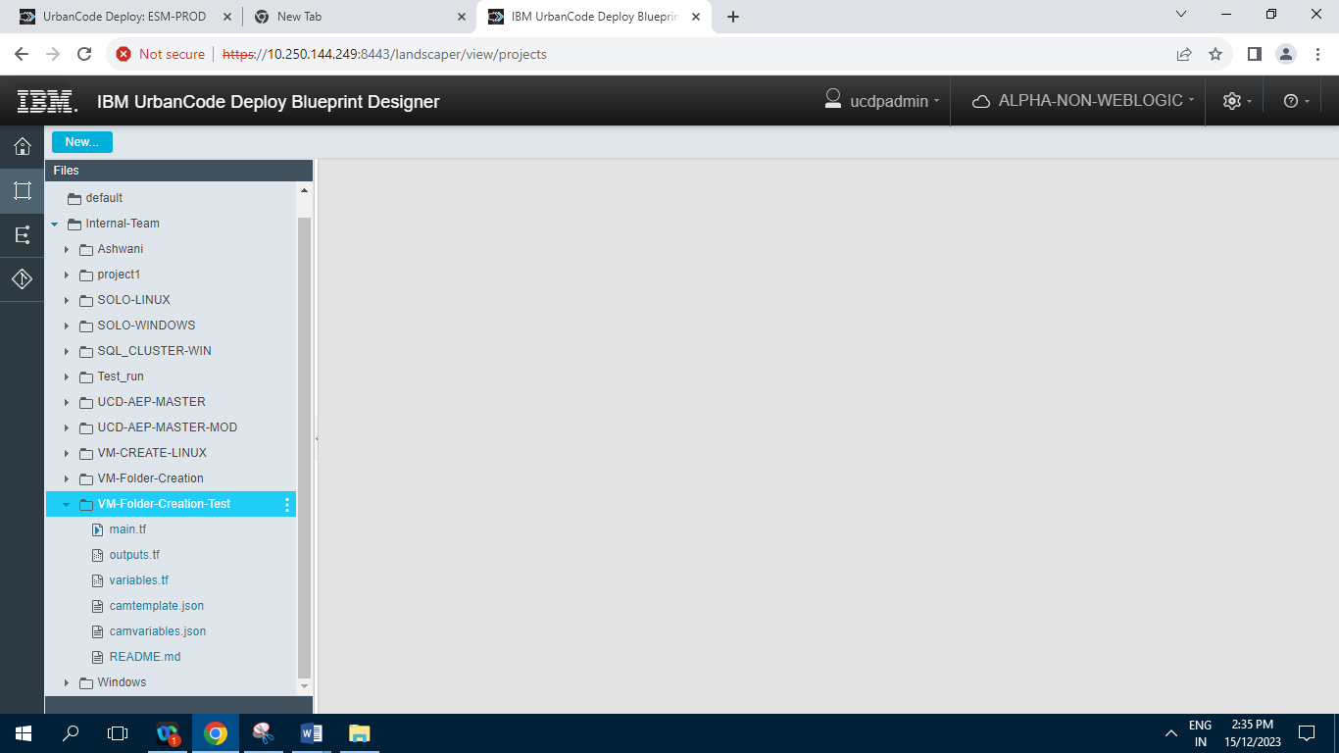

**3.2.12] Windows**

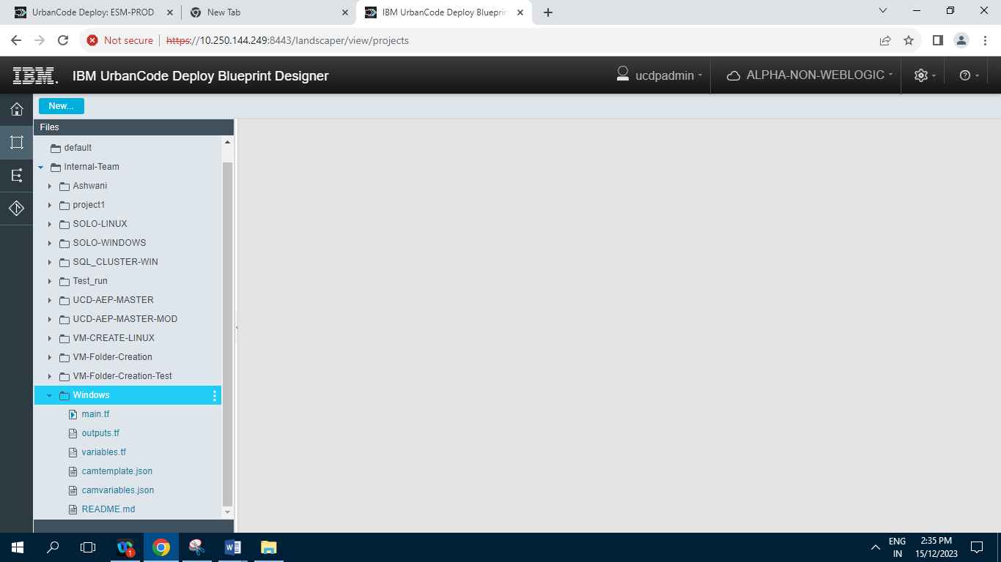

**4] Environments :**

**Terraform-UAT (TERRAFORM) :**

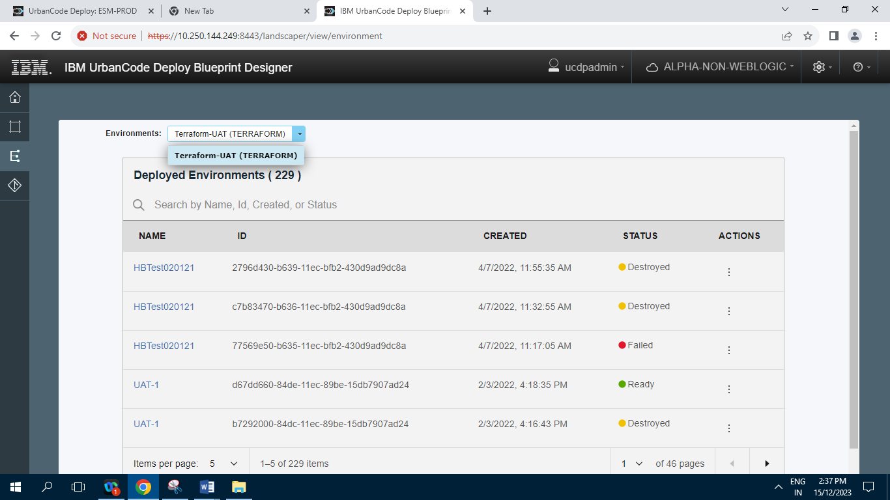

**Records= 229 Items.**

**5] Repositories :**

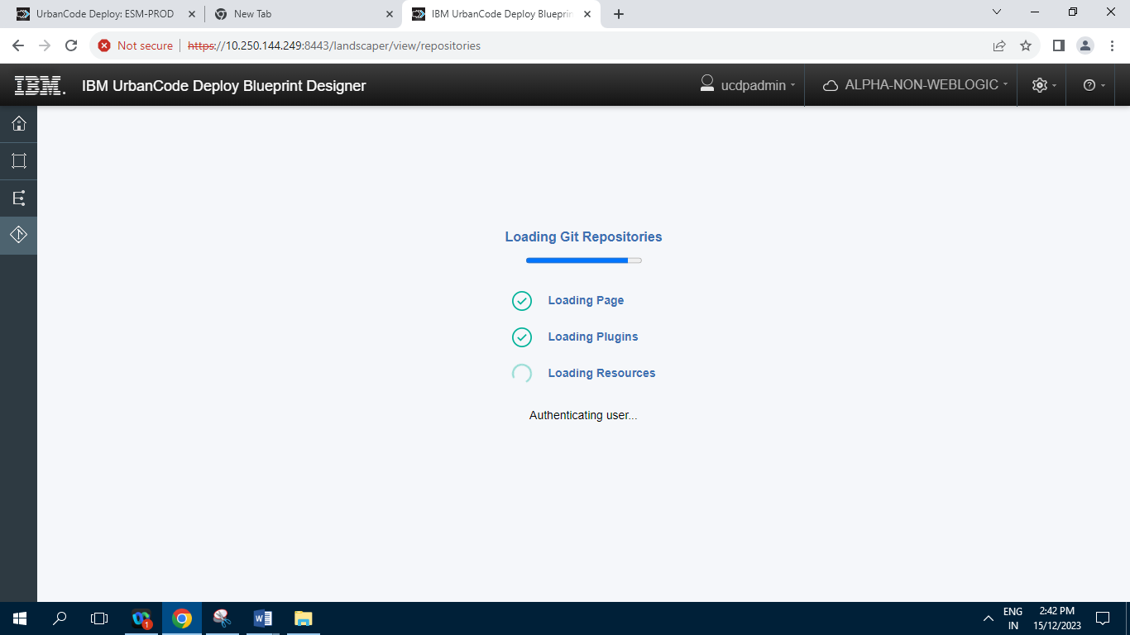

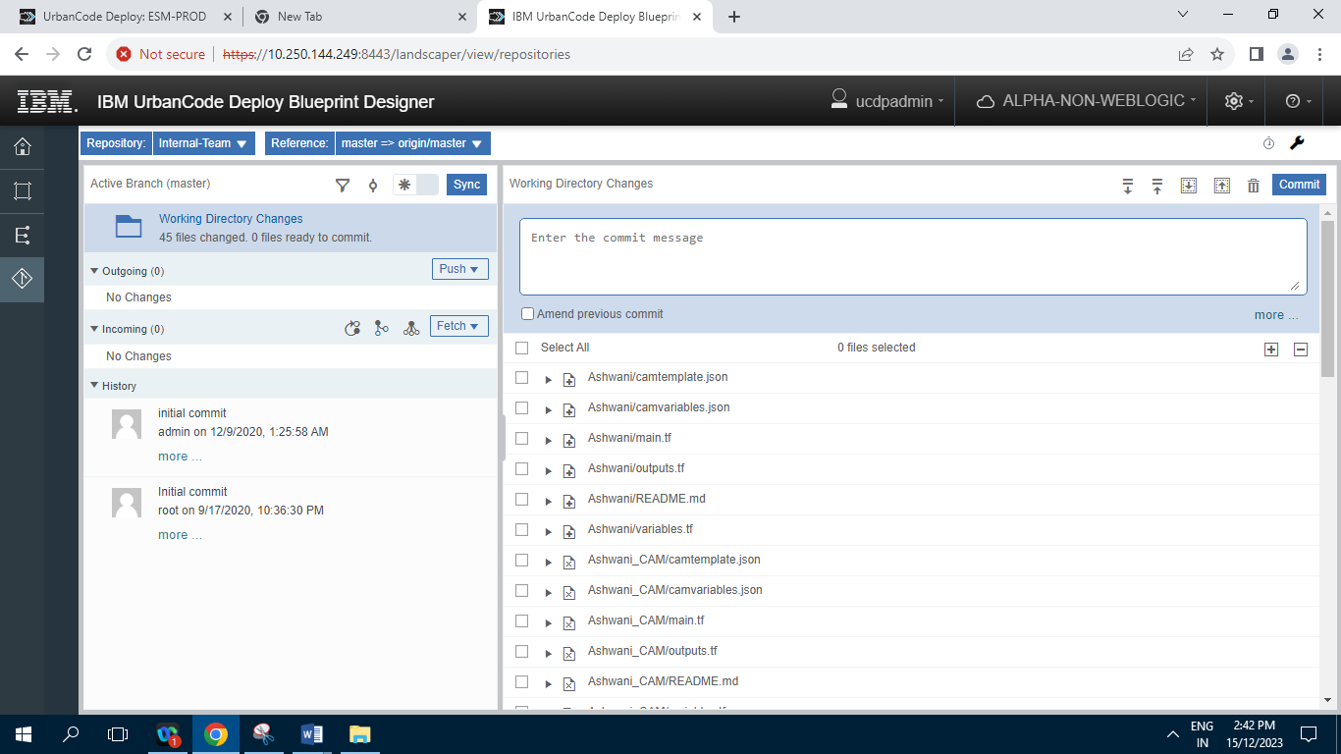

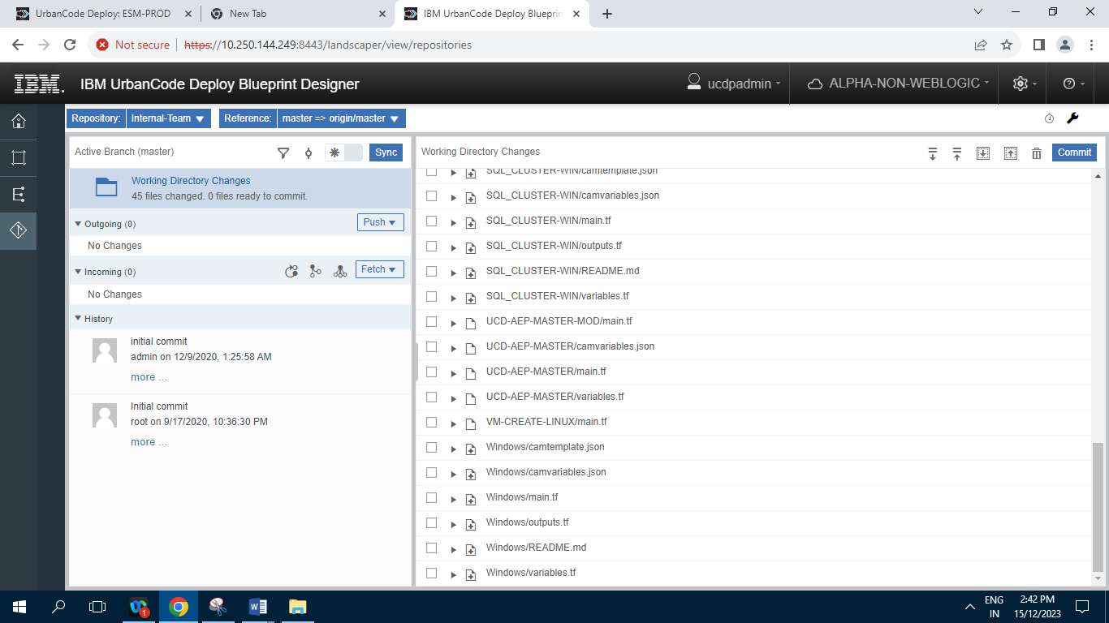

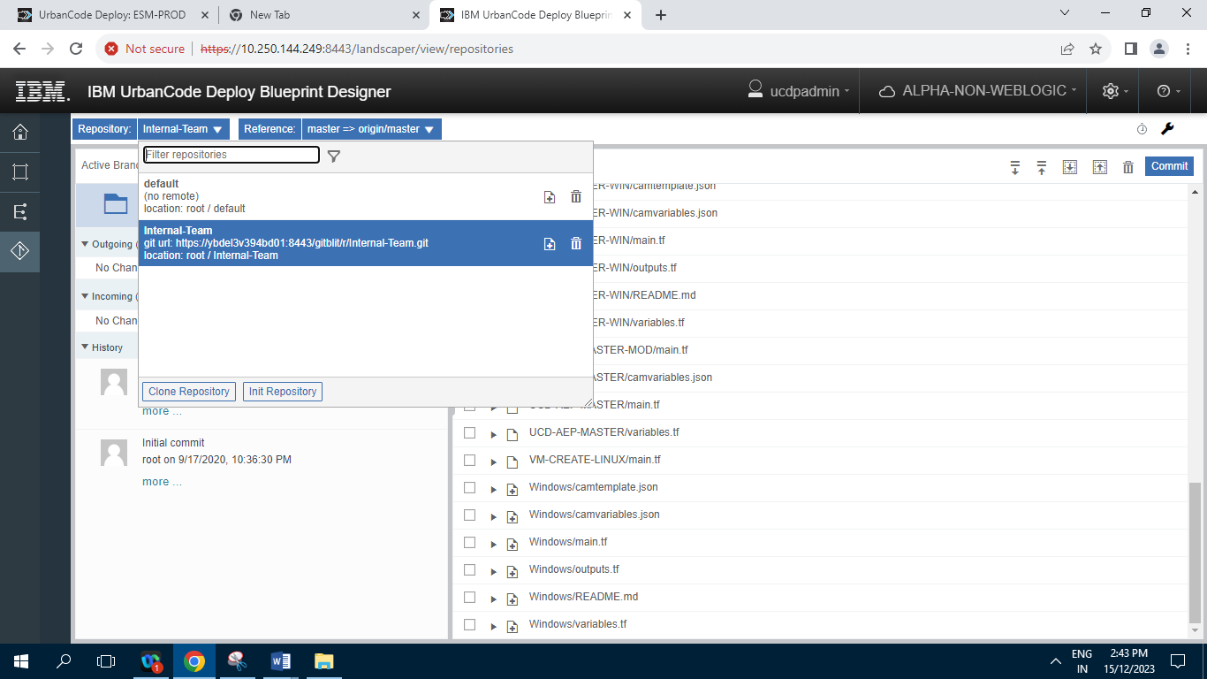

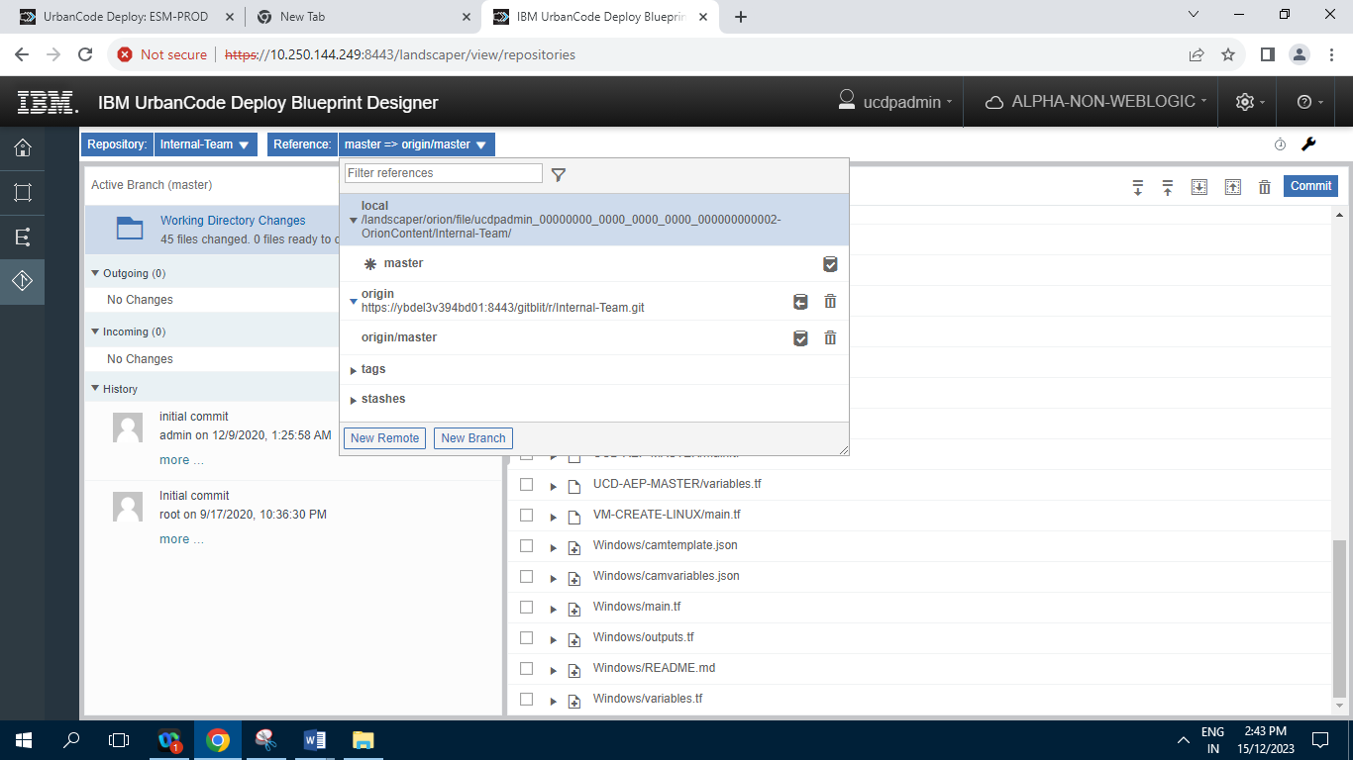

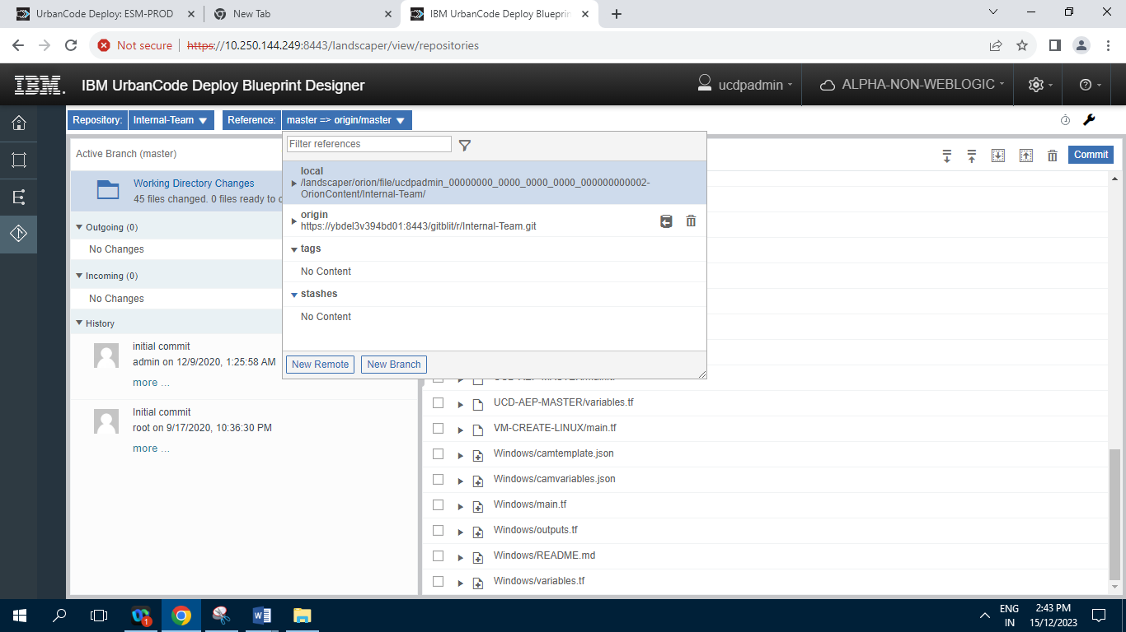

**6] Settings**

**6.1] Users :**

**6.1.1] Internal Authentication**

**6.1.1.1] Users**

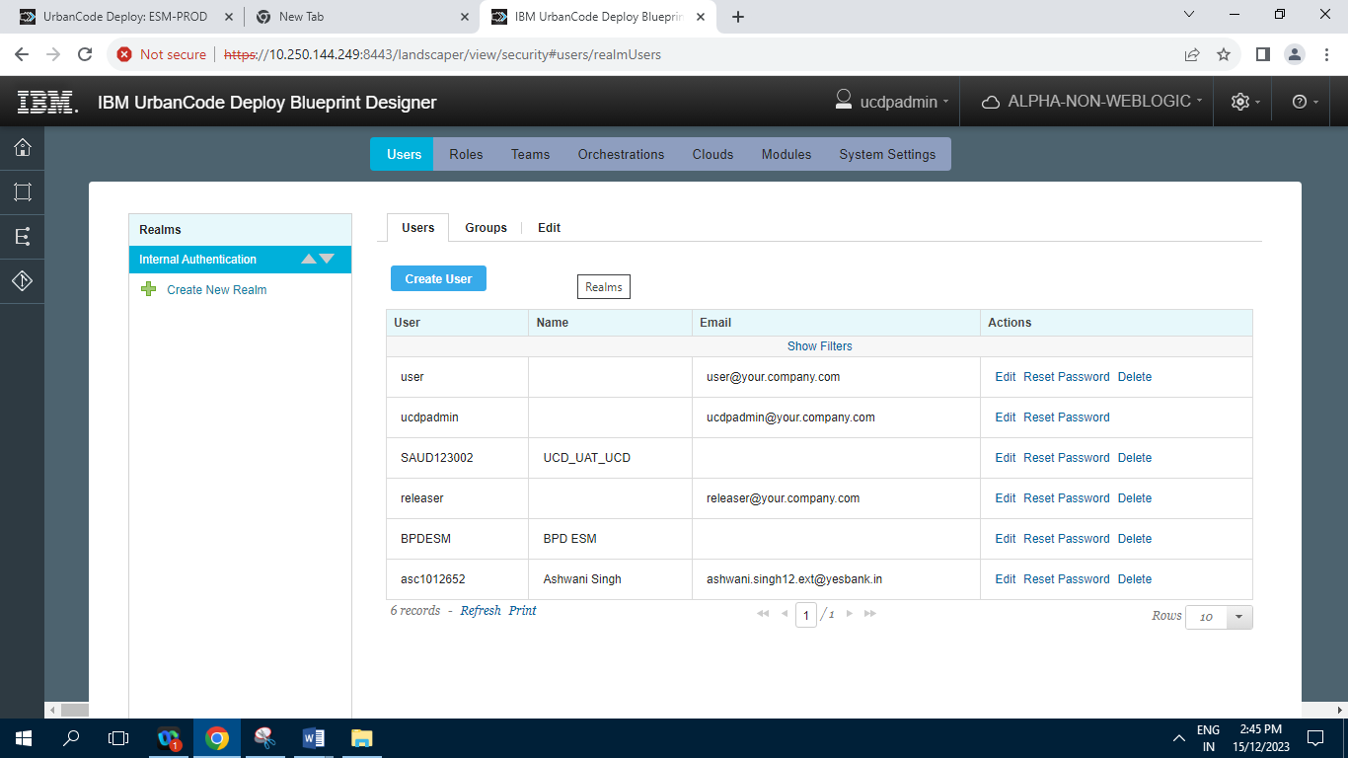

**Records=6**

**6.1.1.2] Groups**

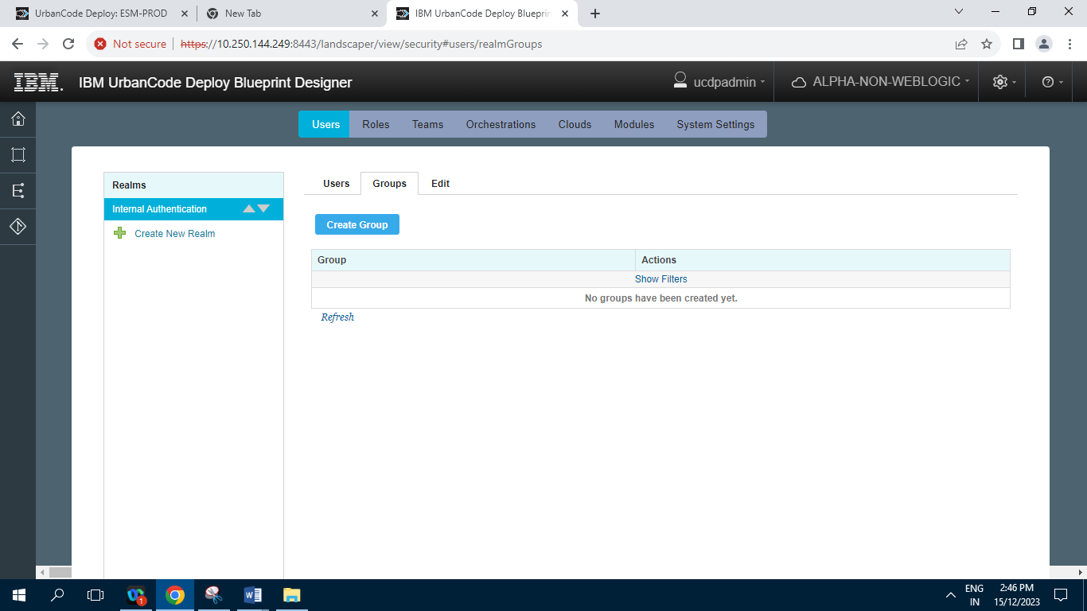

**Record=0**

**6.1.1.3] Edit**

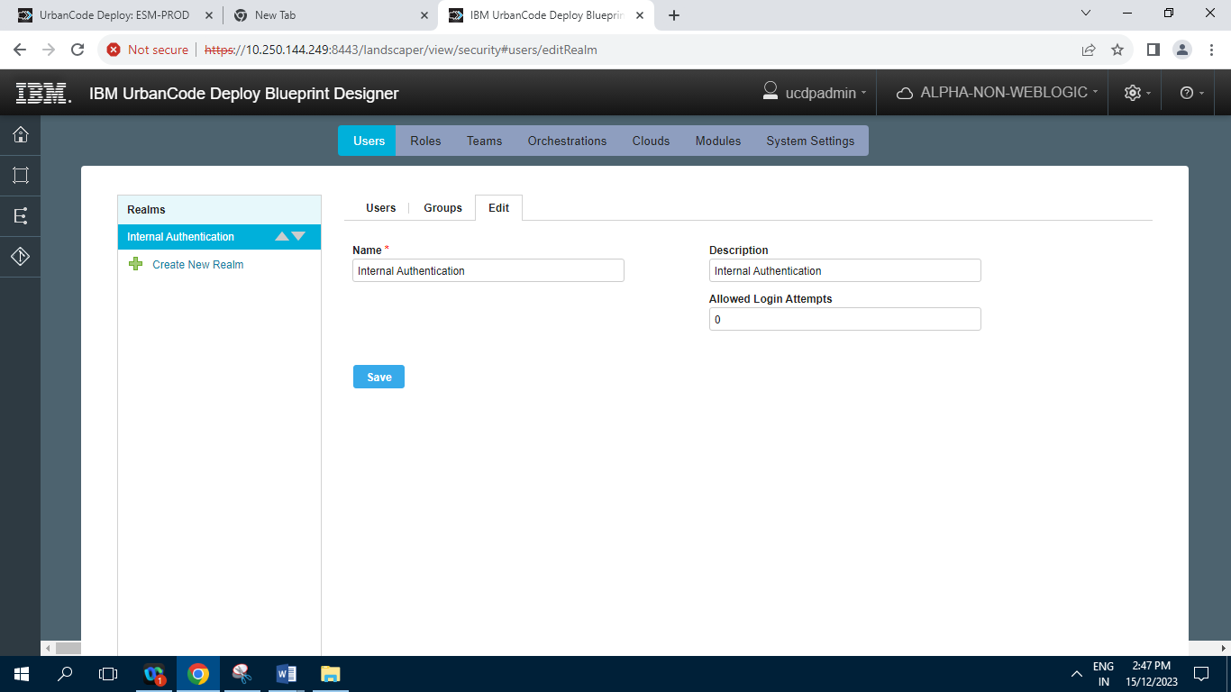

**6.2] Roles :**

**6.2.1] Admin**

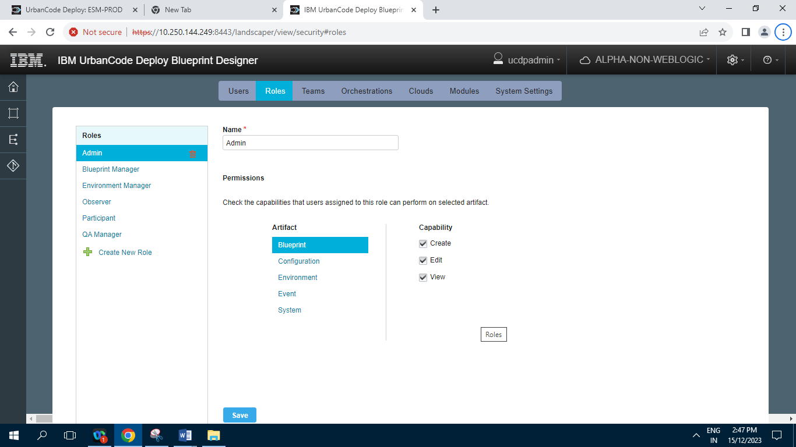

**6.2.2] Blueprint Manager**

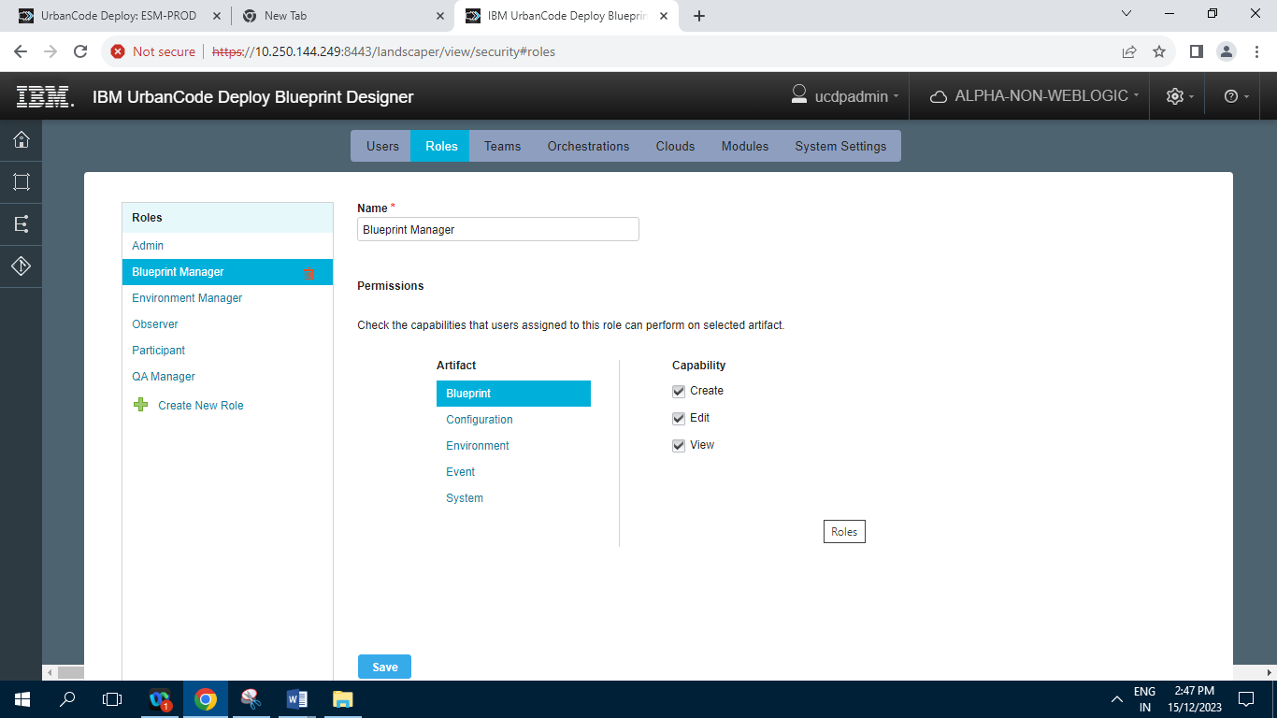

**6.2.3] Environment Manager**

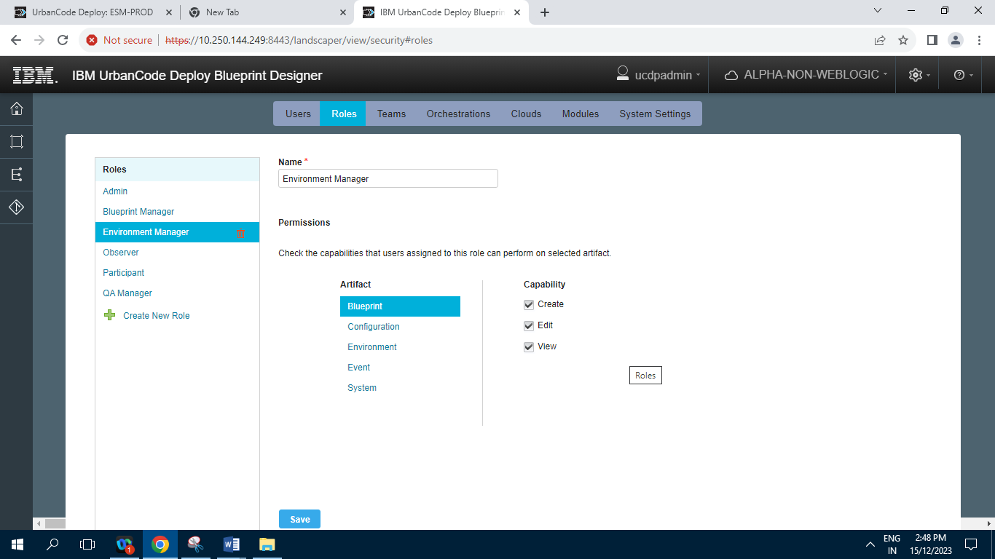

**6.2.4] Observer**

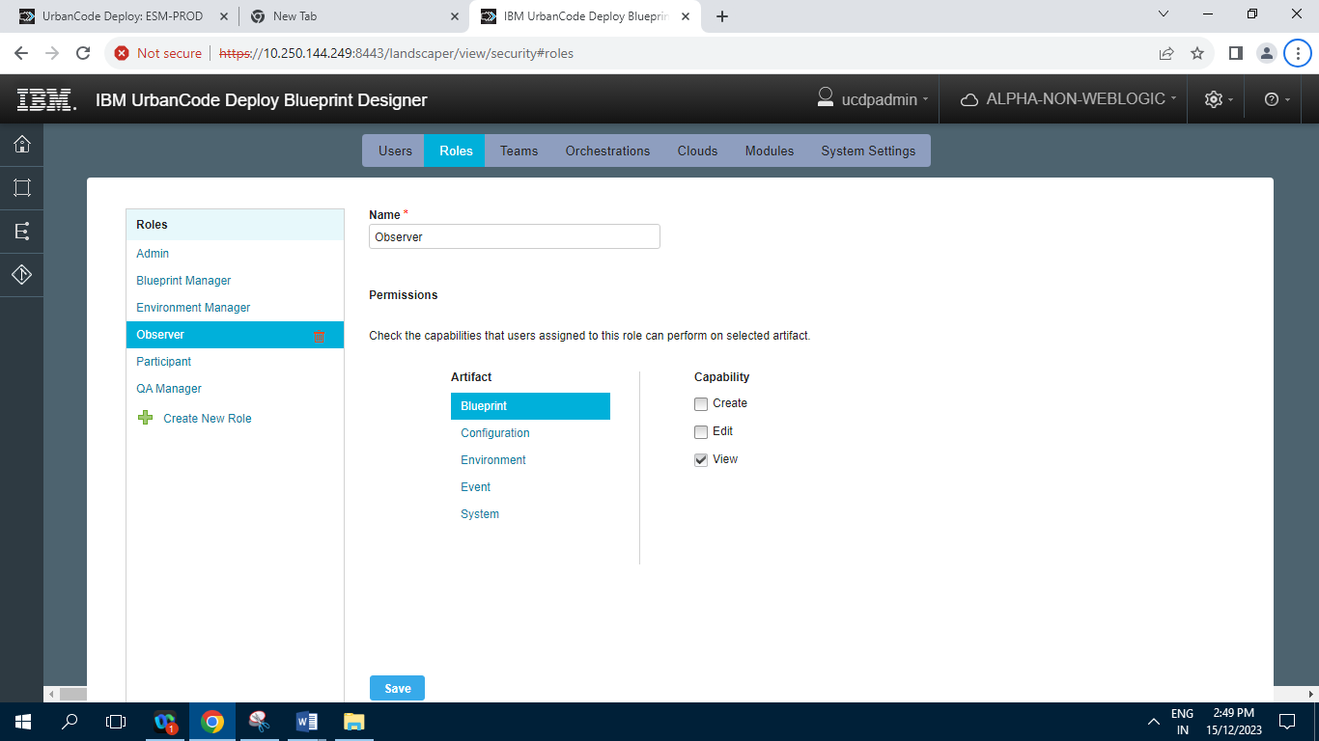

**6.2.5] Participant**

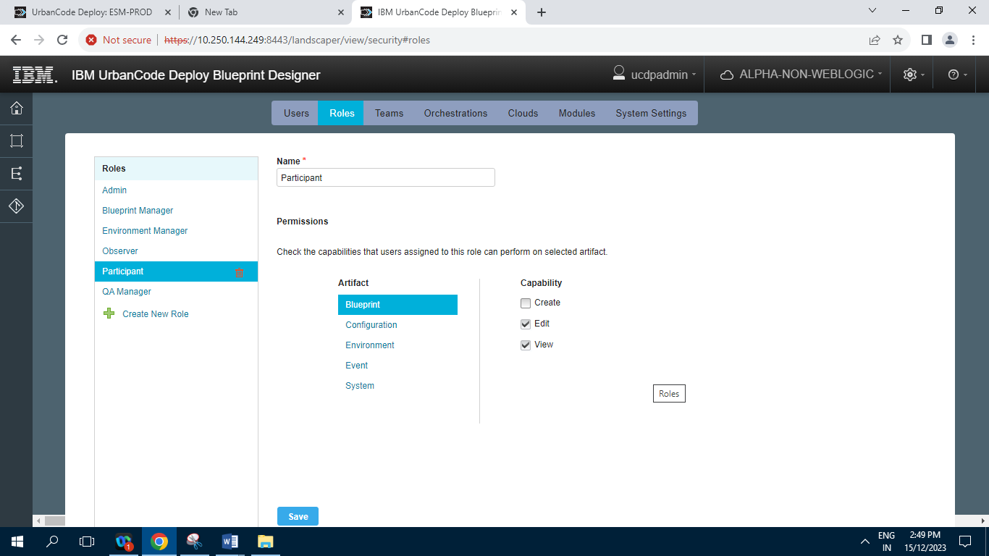

**6.2.6] QA Manager**

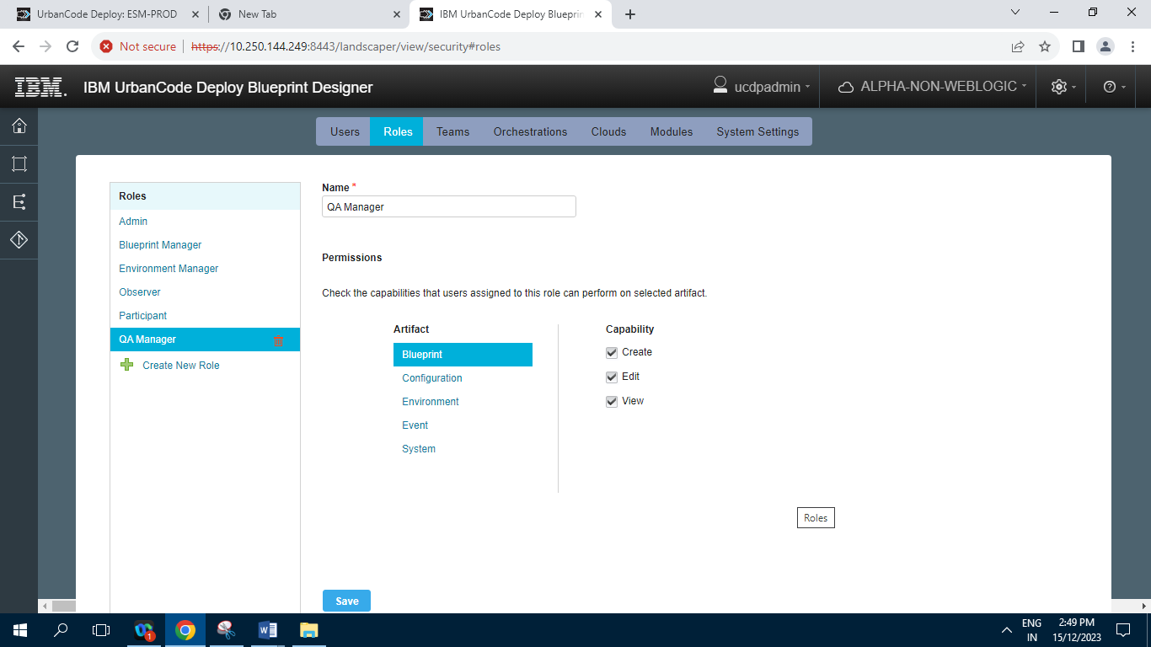

**6.3] Teams**

**6.3.1] Internal Team**

**6.3.1.1] Members**

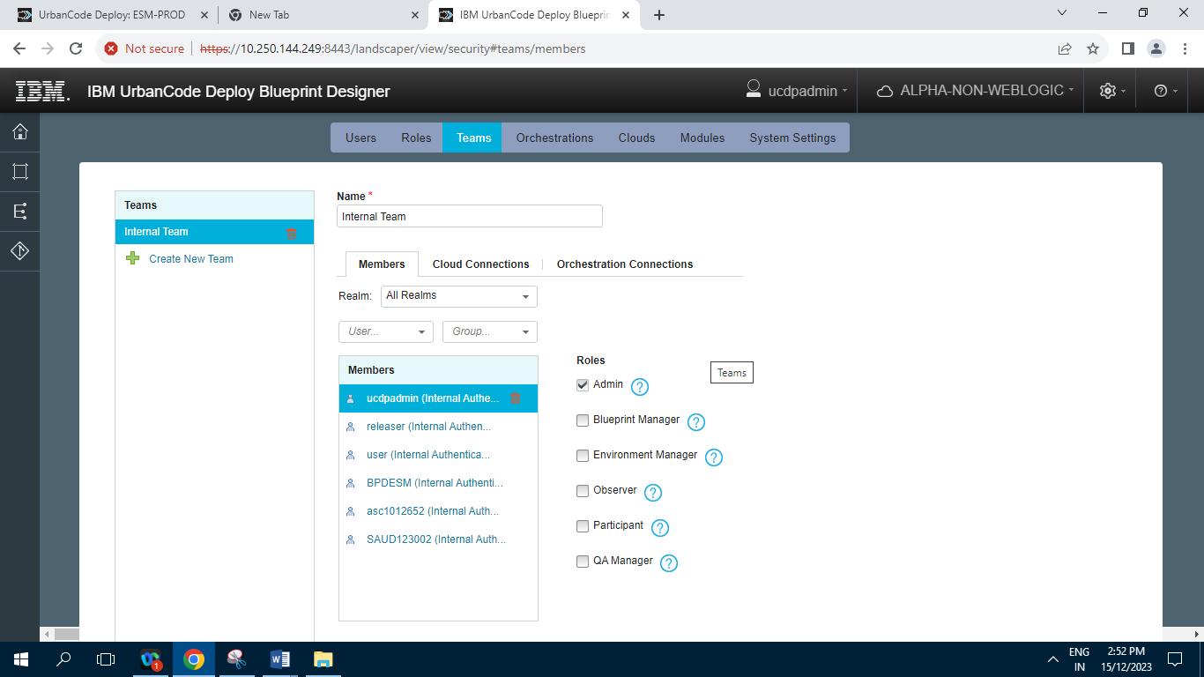

**6.3.1.2] Cloud Connections**

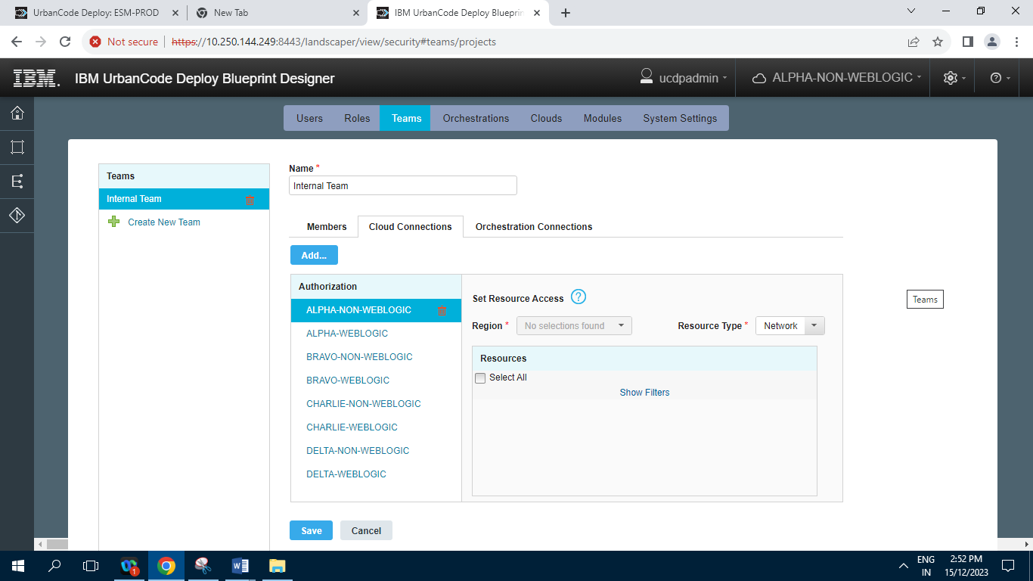

**6.3.1.3] Orchestration Connections**

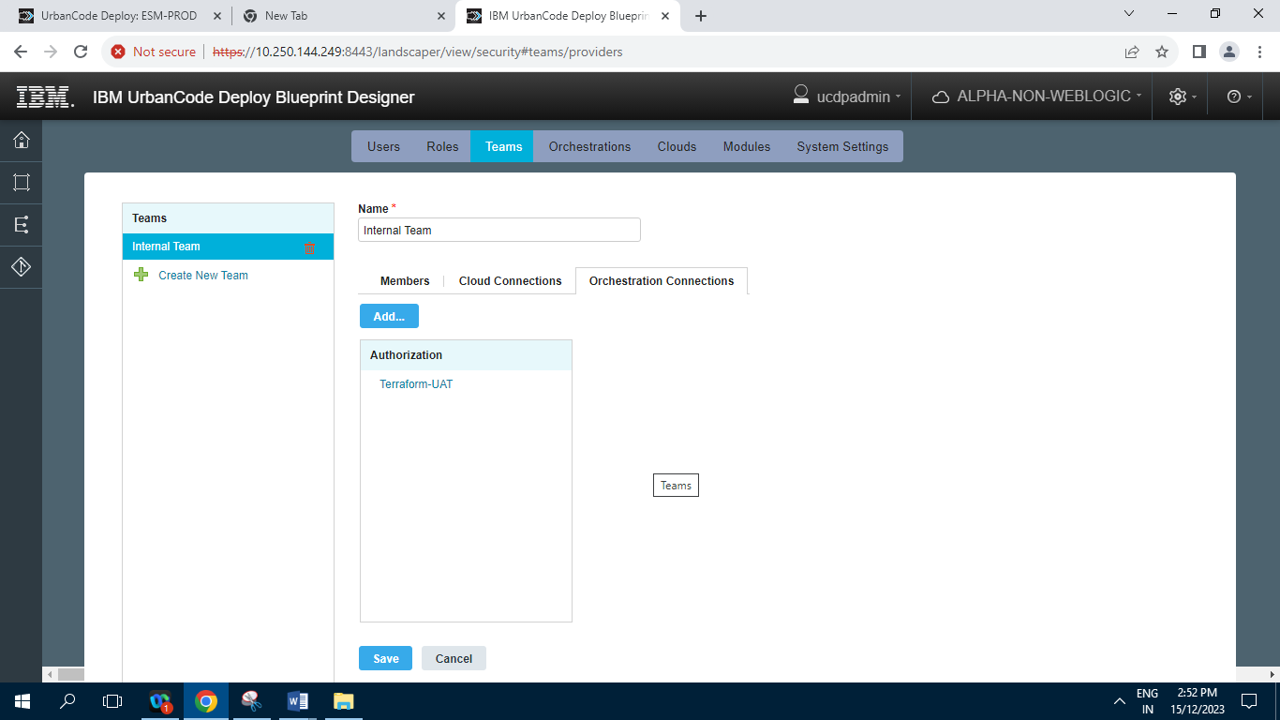

**6.4] Orchestrations**

**6.4.1] Terraform-UAT**

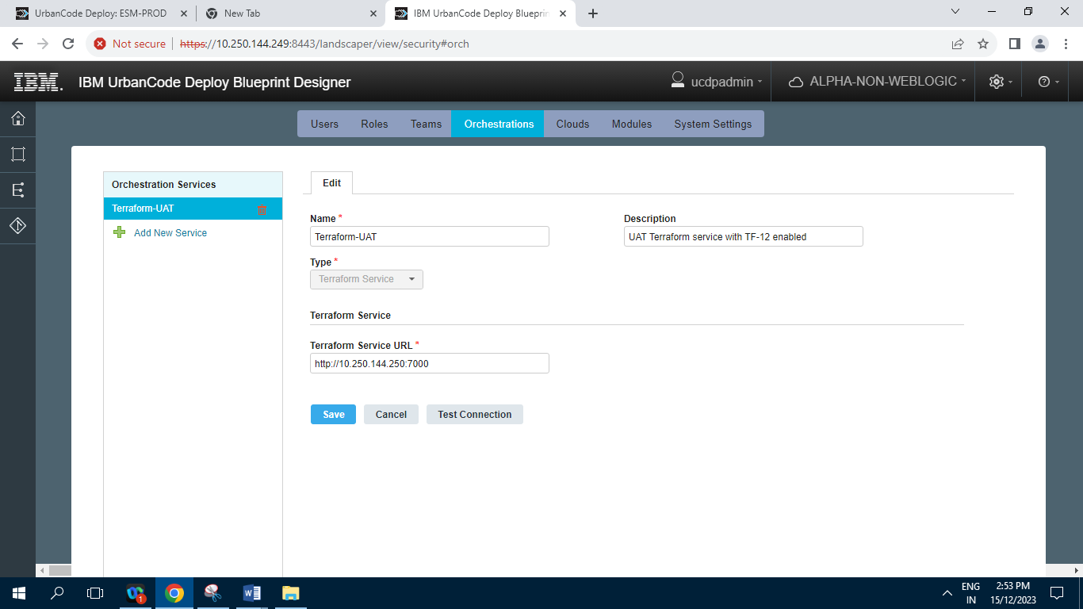

**6.5] Cloud Connections :**

**6.5.1] ALPHA-NON-WEBLOGIC**

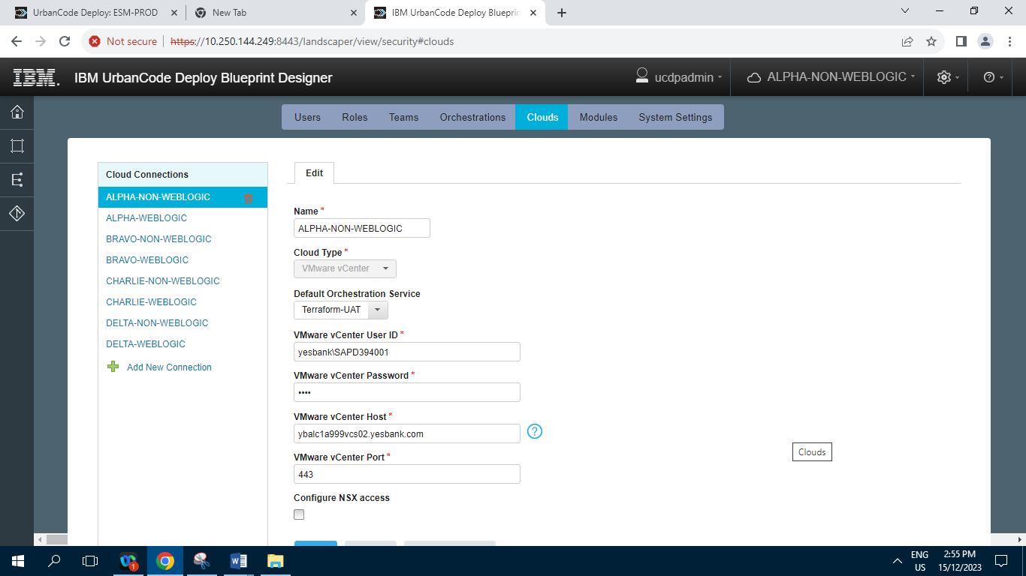

**6.5.2] ALPHA-WEBLOGIC**

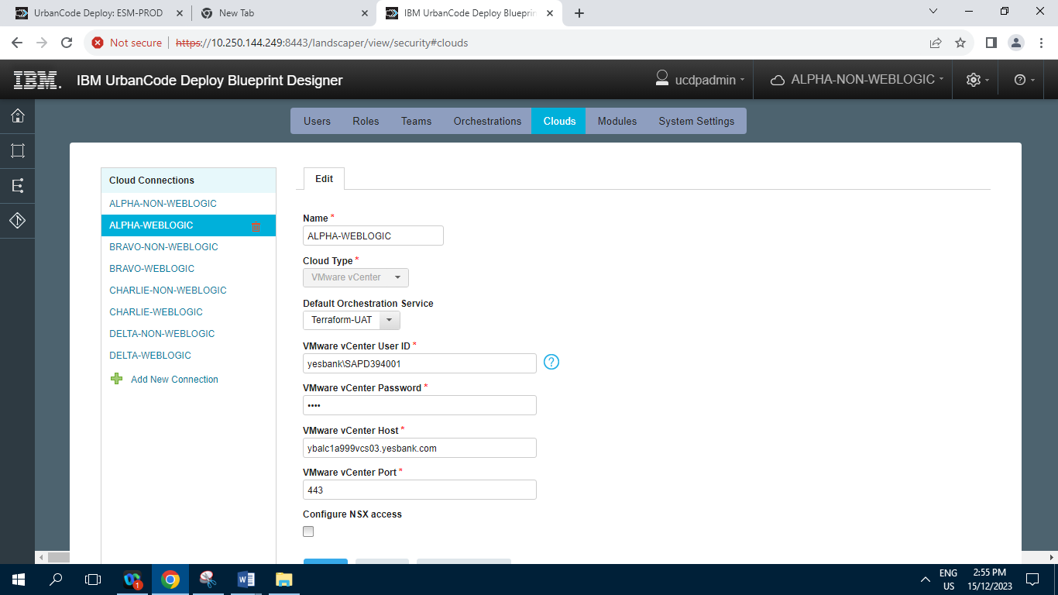

**6.5.3] BRAVO-NON-WEBLOGIC**

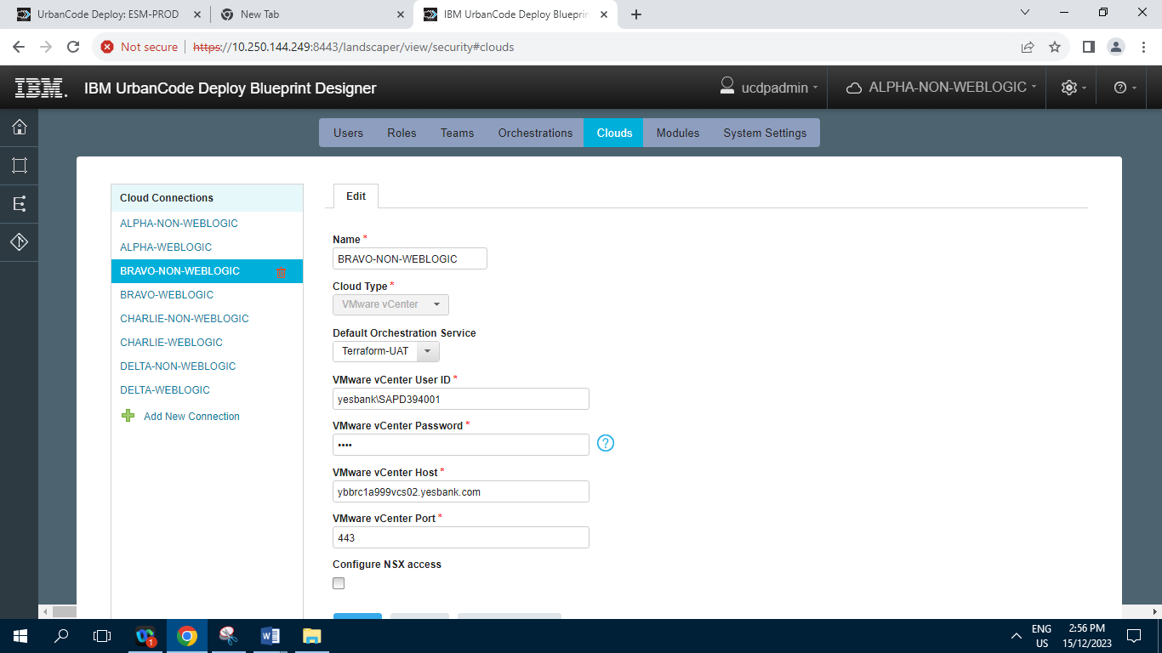

**6.5.4] BRAVO-WEBLOGIC**

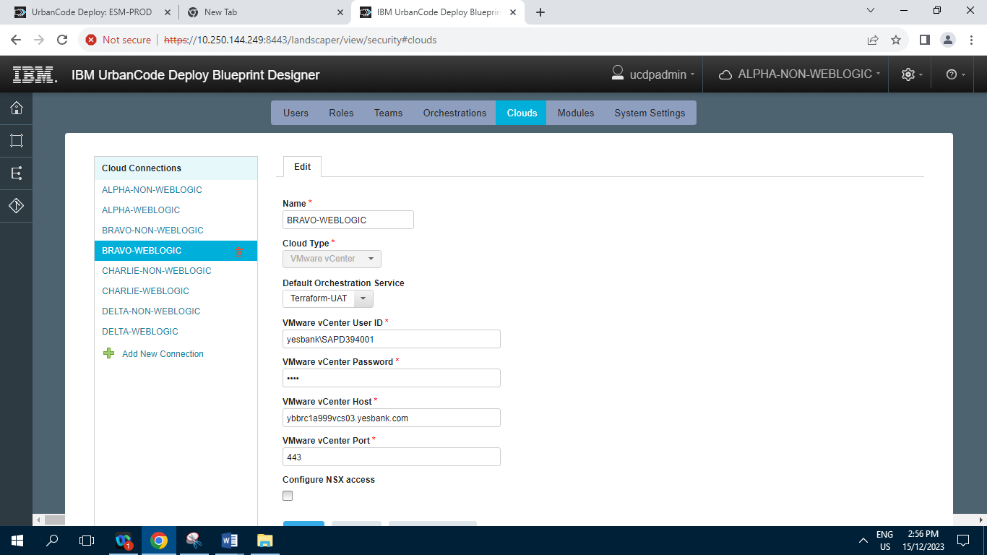

**6.5.5] CHARLIE-NON-WEBLOGIC**

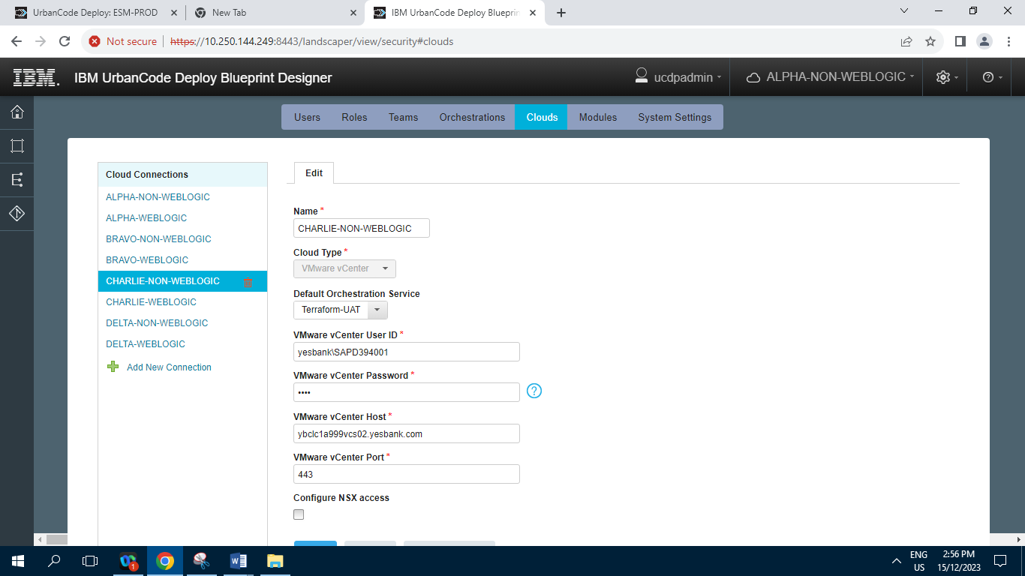

**6.5.6] CHARLIE-WEBLOGIC**

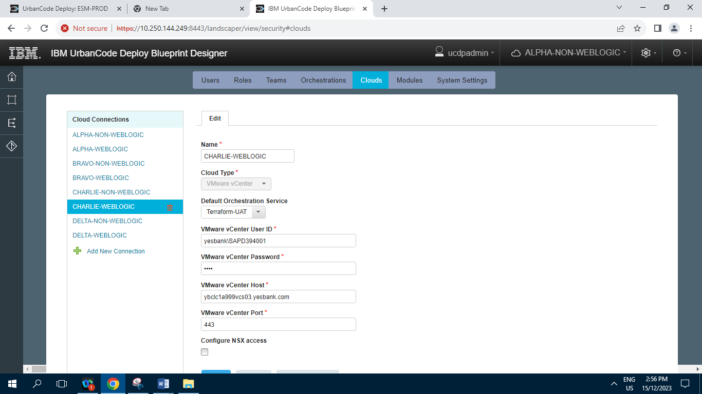

**6.5.7] DELTA-NON-WEBLOGIC**

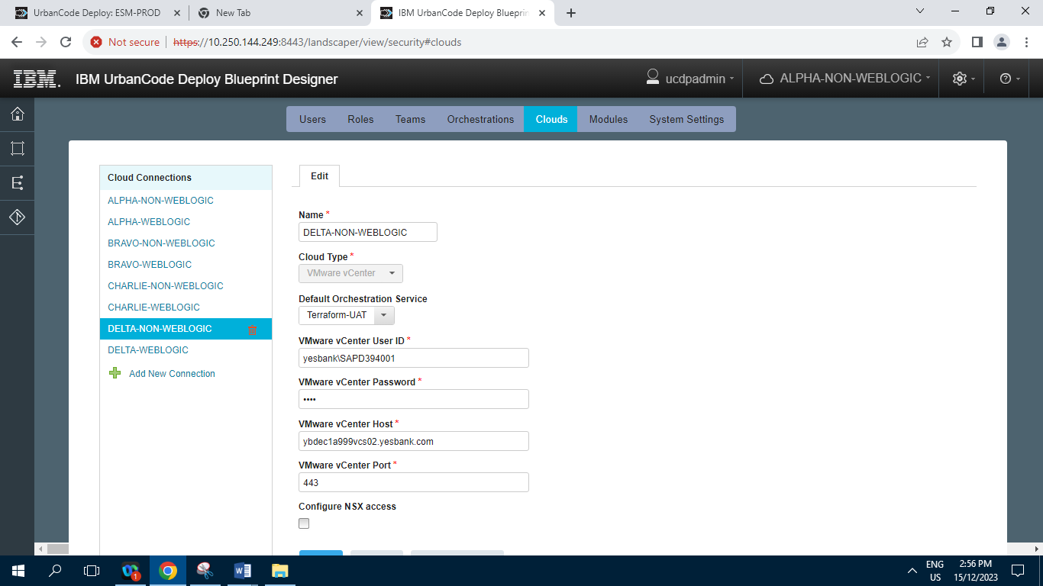

**6.5.8] DELTA-WEBLOGIC**

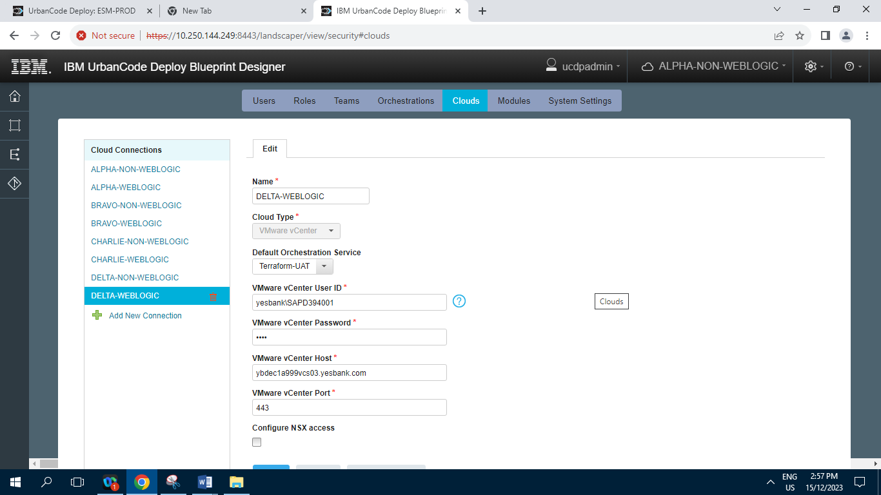

**6.6] Modules**

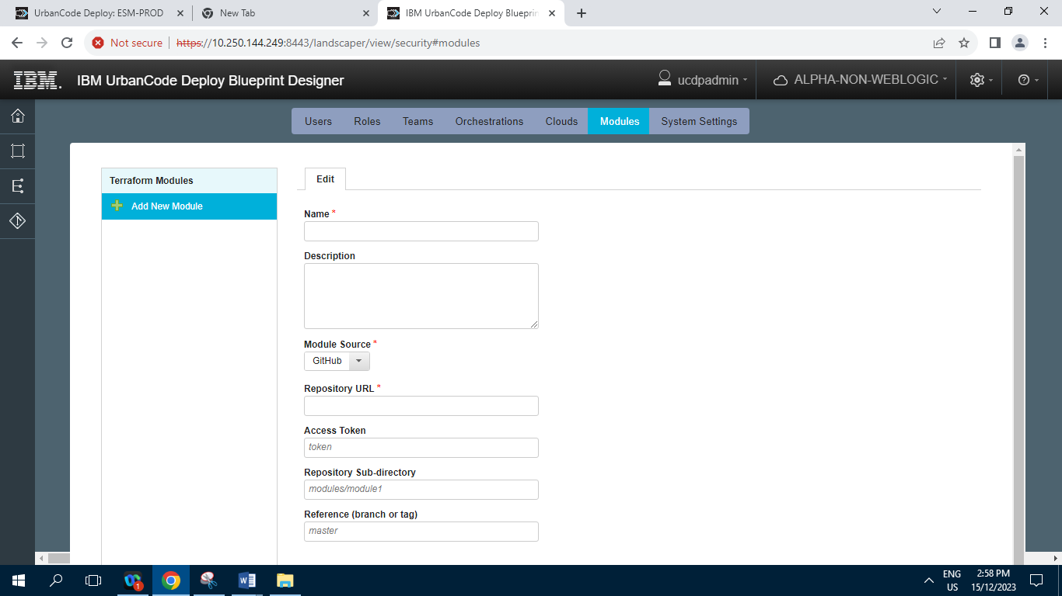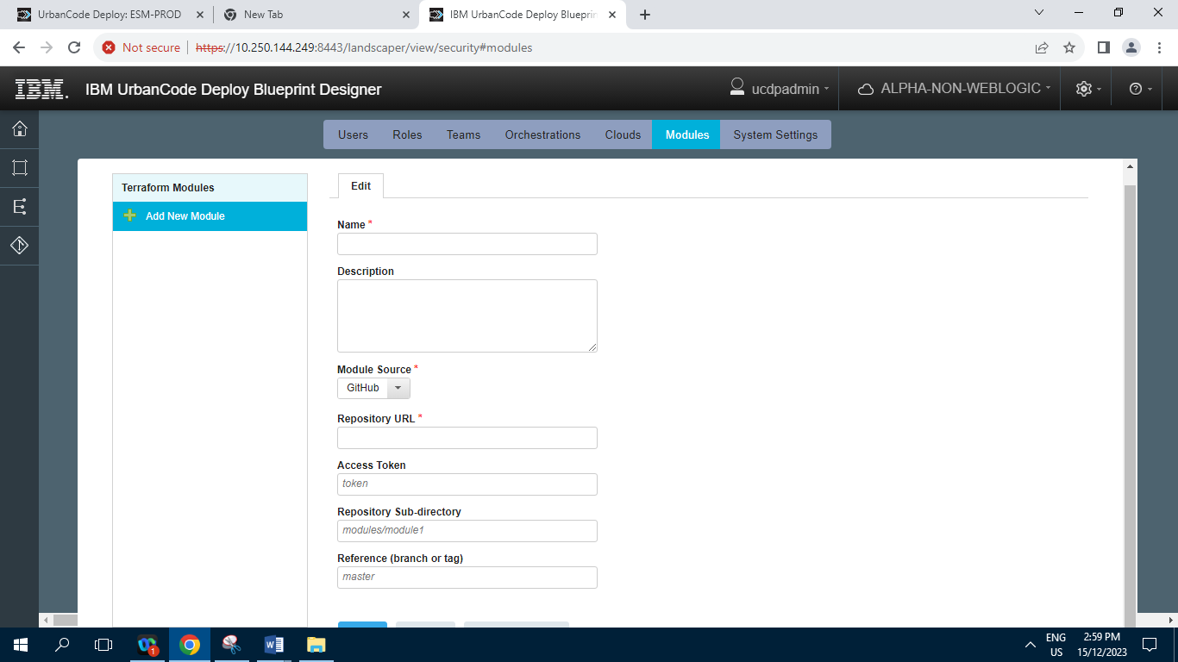

**6.7] System Settings**

